**MODULE 4 ASSIGNMENT 3**

Develop a circuit without microcontrollers for speed control of 6V DC motor with a simple transistor driver to drive the DC motor and protection circuit to avoid reverse current from the motor. Follow the 6 steps involved in electronics prototyping and add the screenshots of the same as .jpg/.png file formats. Add your name and roll number in the Silk layer. The size of the board should be within 100mm x 30mm and Single-sided PCB.

**NAME:**

**YEAR:** SECOND YEAR

**DEPARTMENT:**

**ROLLNO**:

**Requirement Analysis**

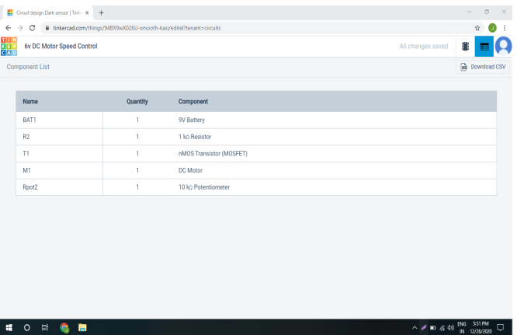

**Quick Design**

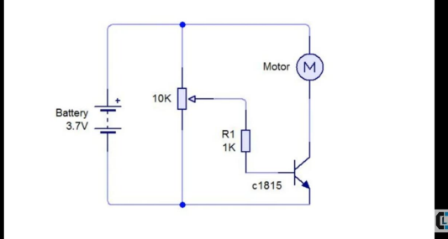

**Build a Prototype**

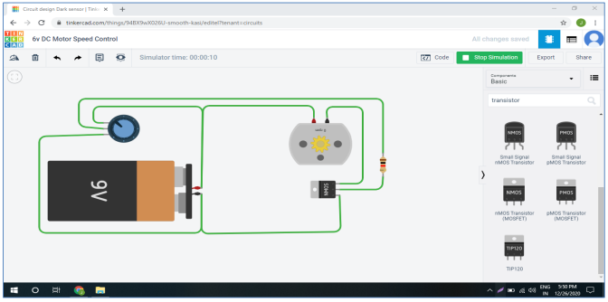

In this picture 1st position in potentialmeter and motor rotates at 0 rpm

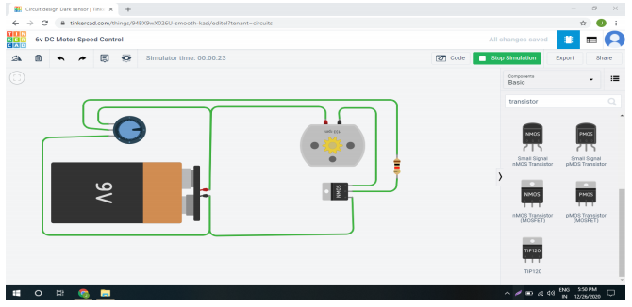

In the above picture 2st position in potentialmeter and motor rotates at 135rpm

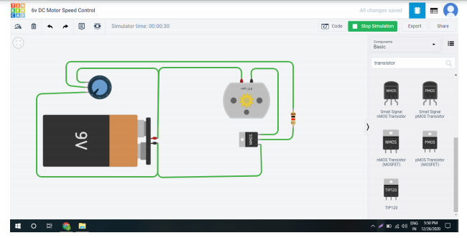

In the above picture 3st position in potentialmeter and motor rotates at 817rpm

**PCB Circuit Diagram**

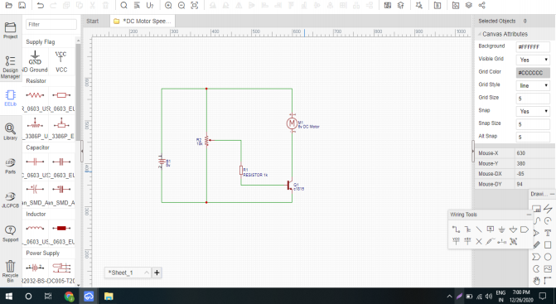

**PCB Diagram**

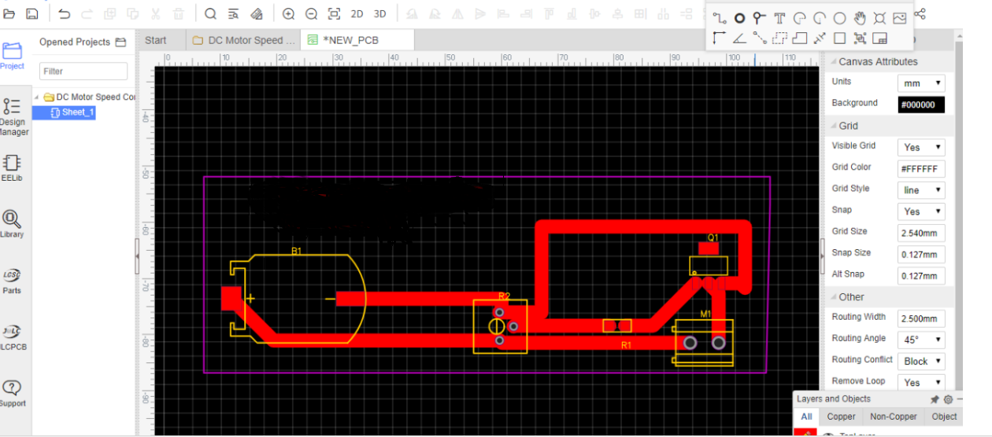

**3D View Of Single-Ended PCB**

